User Manual

**Installation**

Before running the application ensure the following packages in *requirements.txt* are installed using *pip3 install -r requirements.txt*

1. Jinja2 - Template Engine for Python
2. Bleach - HTML sanitising library
3. Pandas - Data Manipulation and Analysis
4. Matplotlib - Data visualisation

**Configuration**

Execution of this application consists of two parts. Firstly, edit *backup.sh*and add directories and files that need to be duplicated for analysis. Running this script outputs a tar archive of a directory called *backup*. The next part includes running the main program *run.py* that takes the name of the backup directory as input. The scripts directory contains log analysis python scripts.

Directory structure of the application

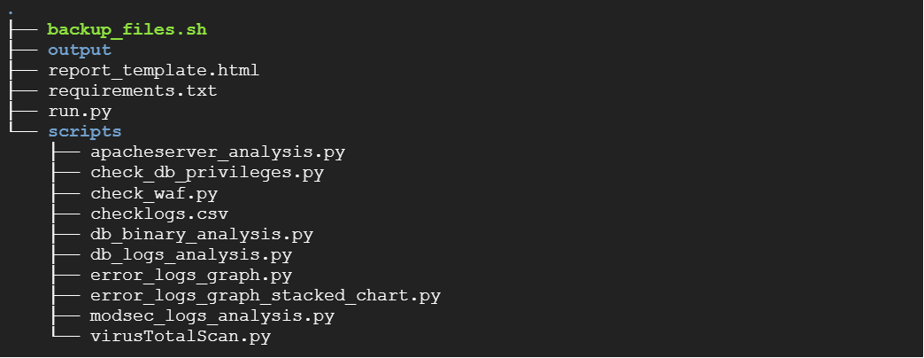

**Usage**

Run *sudo backup_files.sh*

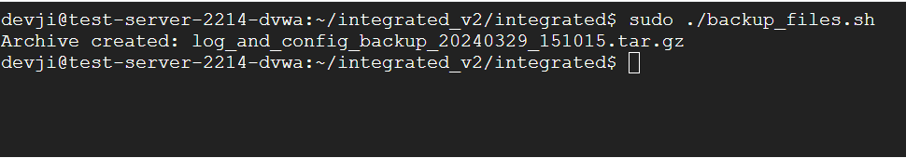

*tar -xvzf log_and_config_backup_20240329_151015.tar.gz*

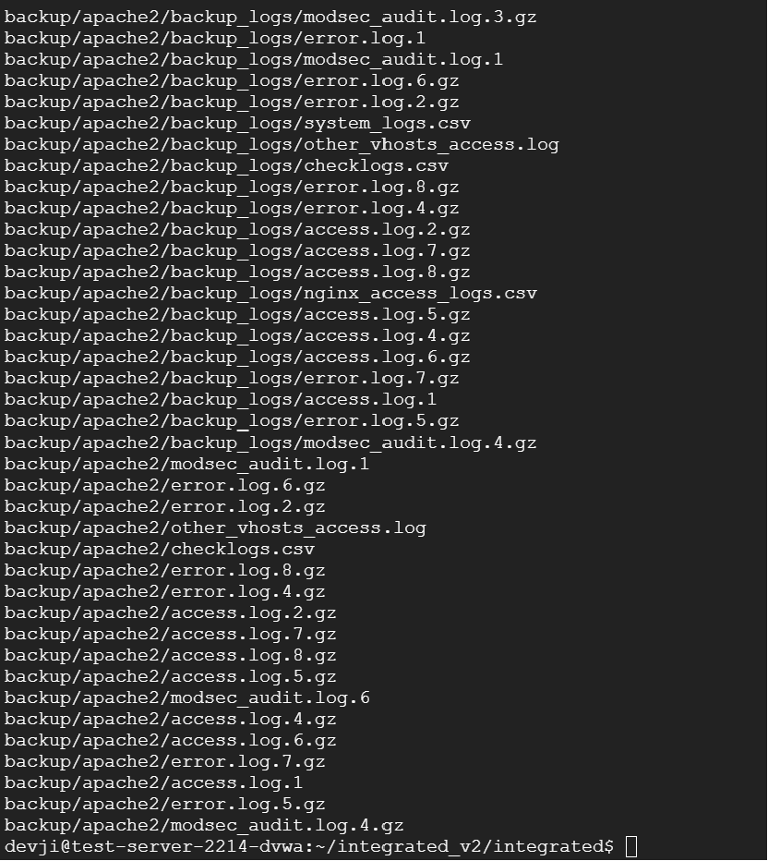

Running the main program - *run.py* generates a *log_analysis_report.html* that contains the results of log analysis.

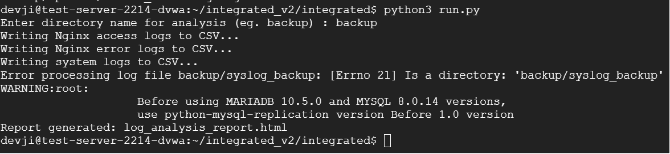

The generated reports can be viewed through a browser.

